Power BI Assignment 2 - DAX, Data Visualization
Calculated Column:

- To calculate category type that combines the 'Category' and 'Sub-Category' columns into a single 'Category Type' column.
DAX: Category Type = CONCATENATE('Order Details'[Category],","&'Order Details'[Sub-Category])

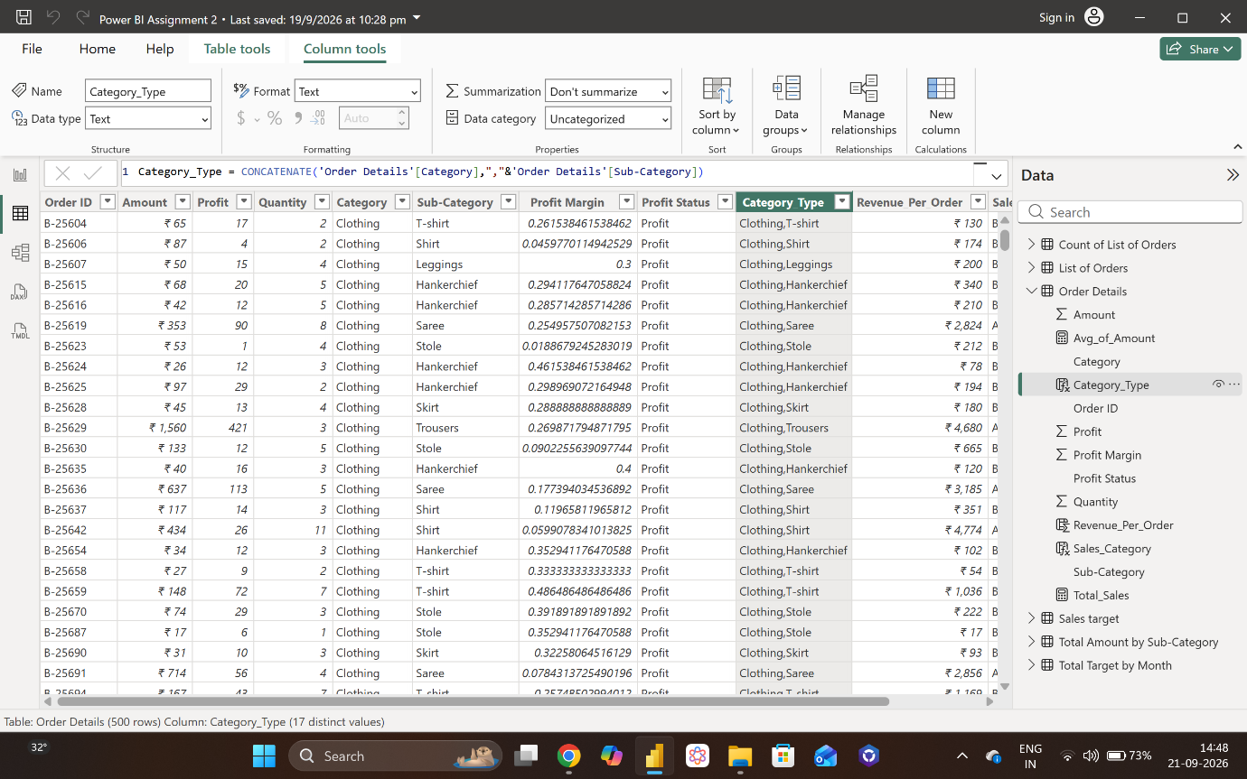

- To compute the revenue (Amount * Quantity) per order.
DAX: Revenue_Per_Order = 'Order Details'[Amount] * 'Order Details'[Quantity]
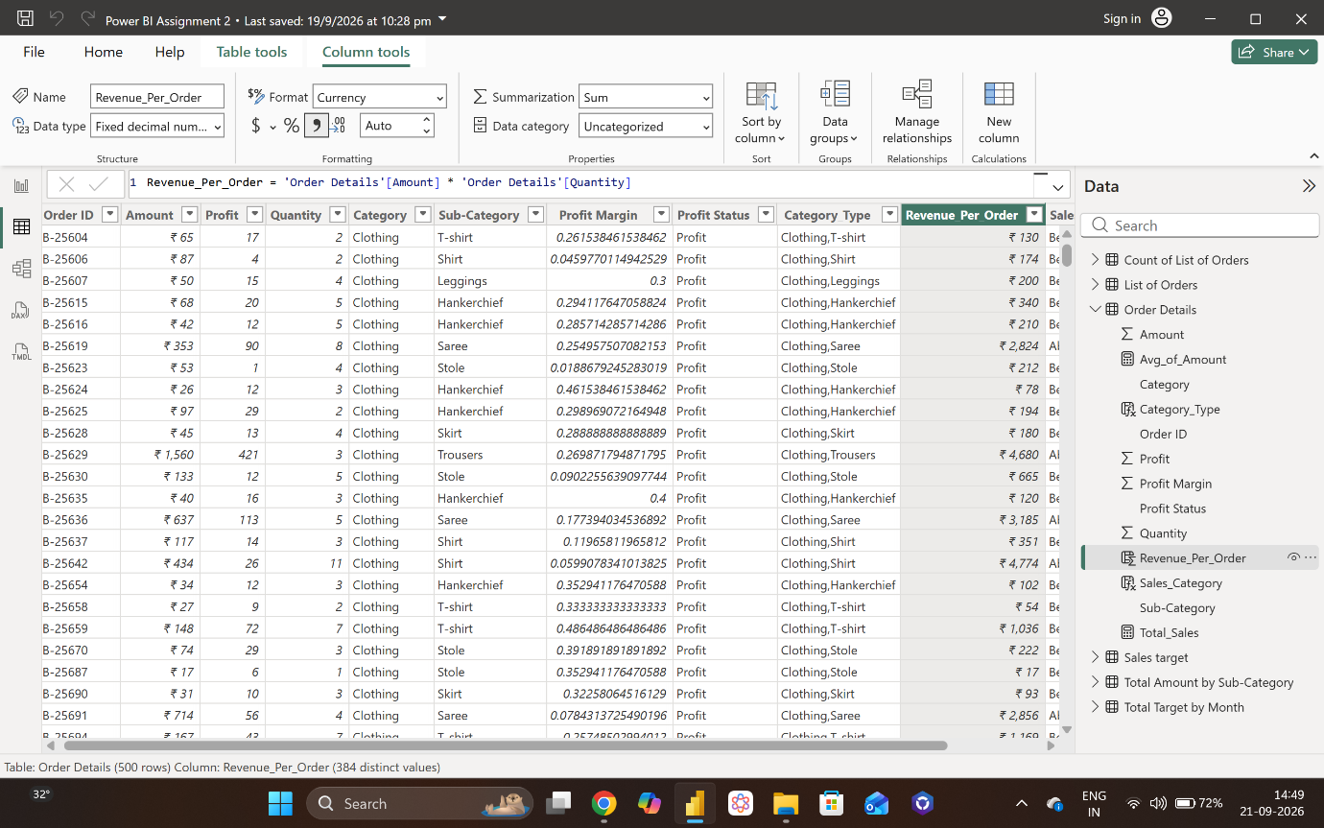
- To categorize each order as 'Above Average' or 'Below Average' based on the Amount value.
DAX: Sales_Category = IF('Order Details'[Avg_of_Amount]>270.33,"Above Average", "Below Average")
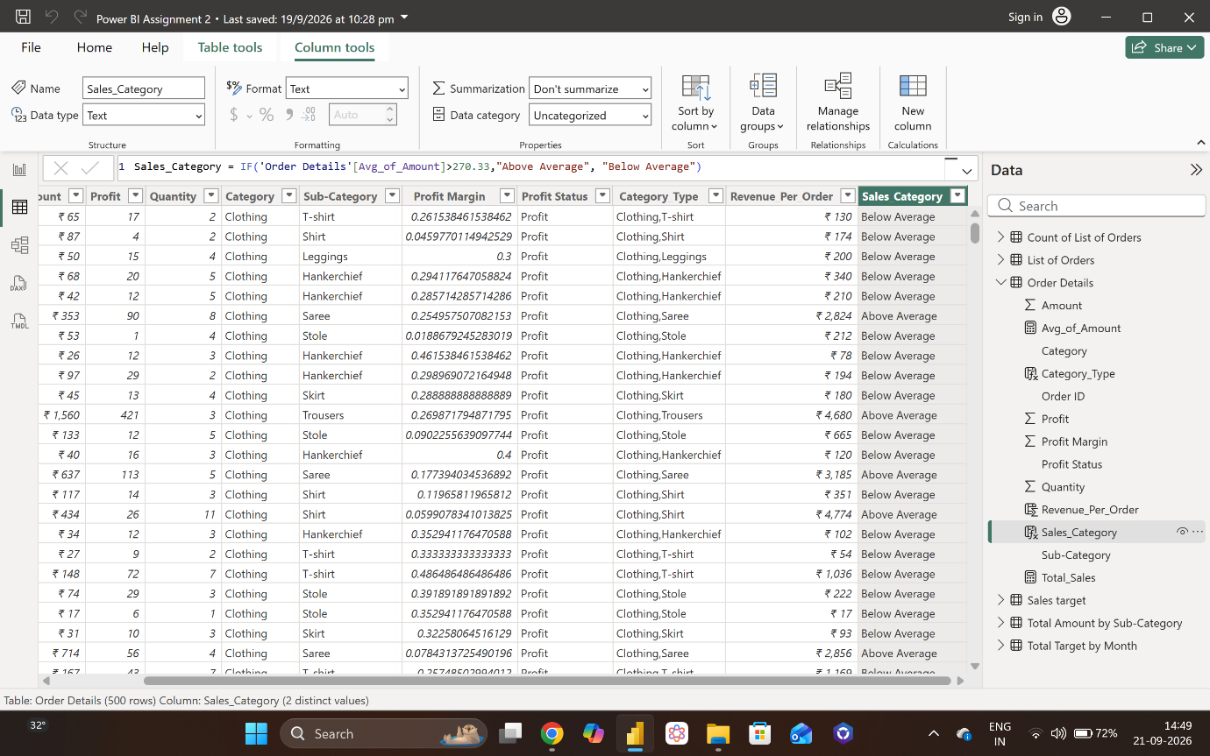

Calculated Measure:
- To count the total number of orders.
DAX: Order_Count = DISTINCTCOUNT('Order Details'[Order ID])
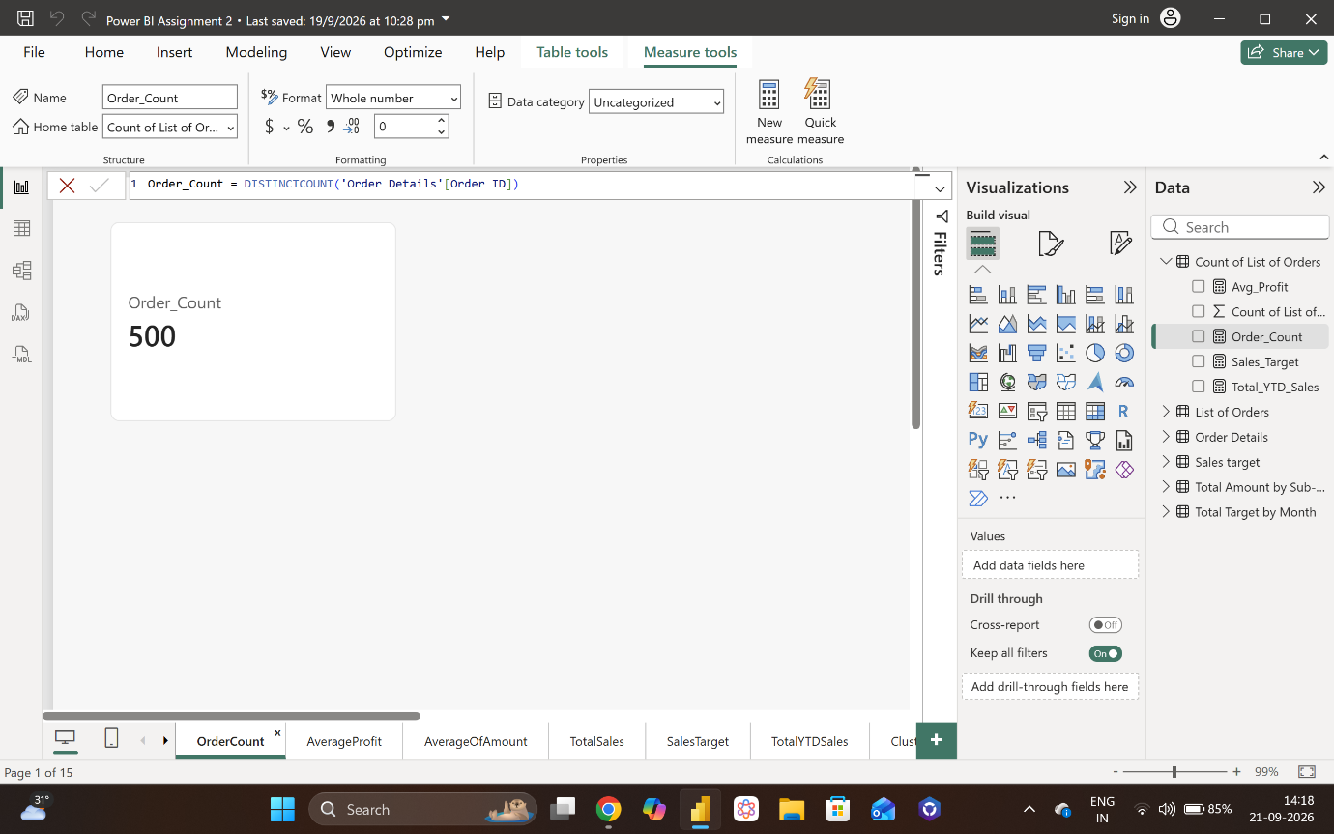
- To calculate the average profit for orders placed in Delhi.
DAX: Avg_Profit = CALCULATE(AVERAGE('Order Details'[Profit]),('List of Orders'[City]= "Delhi"))
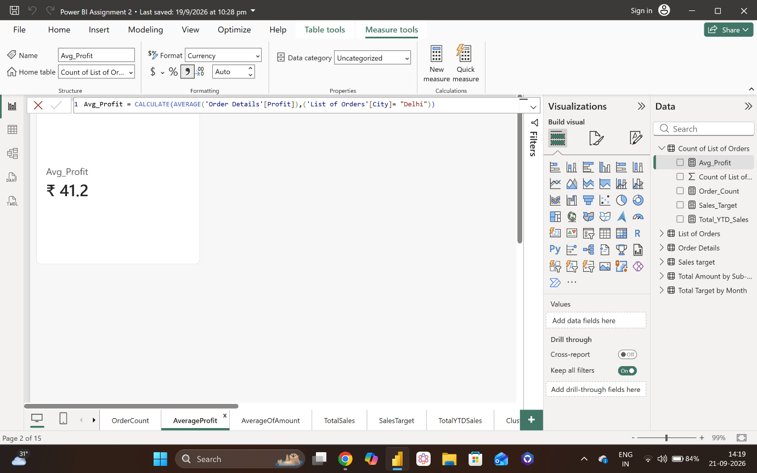
- To calculate the total sales amount accumulated from the earliest order date up to each order date.
DAX: Total_YTD_Sales = TOTALYTD([Total_Sales],'List of Orders'[Order Date])
